

**SERVICES**

**The Praetors**

CONTENTS

1 SOFTWARE DEVELOPMENT 2

2 ANDROID APP DEVELOPMENT 12

3 IOS APP DEVELOPMENT 21

# SOFTWARE DEVELOPMENT

**META TITLE**: Custom Software Development Services | The Praetors

**META DESCRIPTION**: Discover tailored software solutions for your business needs. Experience seamless integration & ongoing support with your reliable custom software application development company!

**URL**:

**[BANNER 1]**

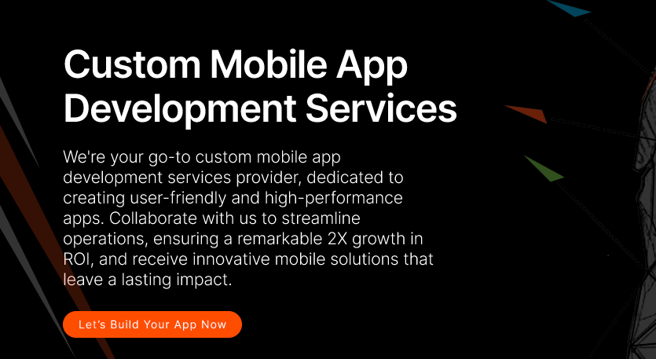

**Custom Software Development Services**

Empower your business with our resilient, safeguarded, and adaptable bespoke software offerings. Our customized solutions are engineered to fortify your operations, ensuring reliability and growth. We specialize in crafting custom software solutions that seamlessly integrate with your unique requirements, providing a secure foundation for your digital endeavors. Trust us to deliver scalable solutions that evolve with your business, propelling you towards sustained success in today’s dynamic landscape.

**[LET’S BUILD YOUR SOFTWARE NOW]**

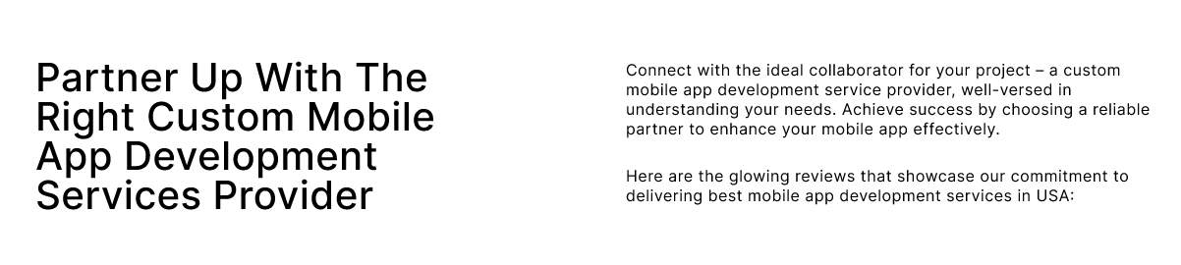

**Personalized And Pre-Packaged Software Development Solutions For Your Unique Business Needs**

An industry-leading custom software development company, The Praetors leads the charge in custom software development and digital innovation. We partner with global enterprises and startups alike to deliver top-notch solutions. Our comprehensive software services cover the entire development spectrum, from inception to deployment, ensuring robust security and seamless maintenance.

Whether it's enhancing existing platforms, pioneering prototype applications, or architecting sophisticated enterprise solutions, our diverse team of experts is strategically positioned worldwide to deliver swift, reliable software development solutions.

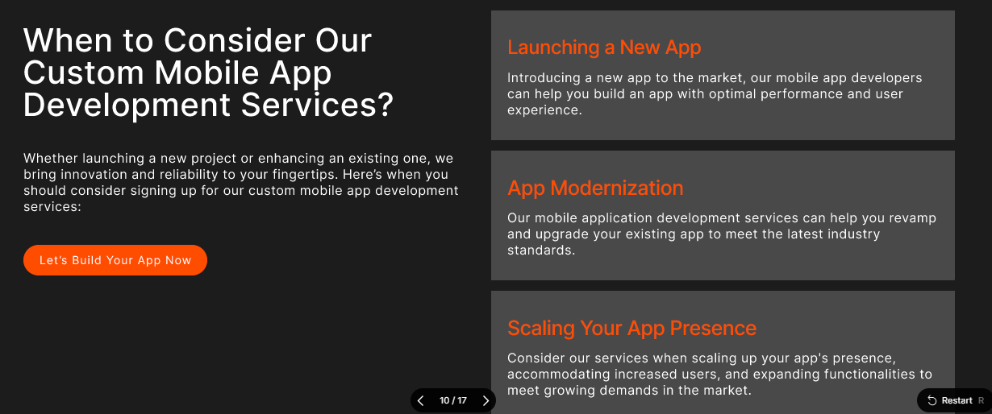

**Gain the Edge with Our Bespoke, AI-First Software Product Development Services** Top of Form

With decades of invaluable experience and deep-rooted industry-specific expertise, we enable organizations to spearhead innovation and cultivate sustainable growth. Our bespoke approach emphasizes the integration of cutting-edge artificial intelligence technologies, positioning businesses to navigate and excel within the dynamic currents of modern industry.

With The Praetors’ custom software development, you can reap the benefits including but not limited to streamlined operations, enhanced productivity, actionable insights, improved customer experiences, and future-proof technology solutions.

|  |  |
| --- | --- |
| **Engineering Excellence** | Built on design-driven principles and a product-centric mindset, our solutions seamlessly integrate with business operations and scale effortlessly, ensuring innovation and adaptability at every turn. |
| **Agile Development** | Adopting an agile methodology, we offer enhanced control, flexibility, and risk mitigation throughout the development lifecycle, accelerating time to market and maximizing return on investment. |
| **Operational Efficiency** | Utilizing offshore, nearshore, and blended shore capabilities, we leverage time zone variances to our advantage, providing round-the-clock development and support services for unmatched operational efficiency and customer satisfaction. |

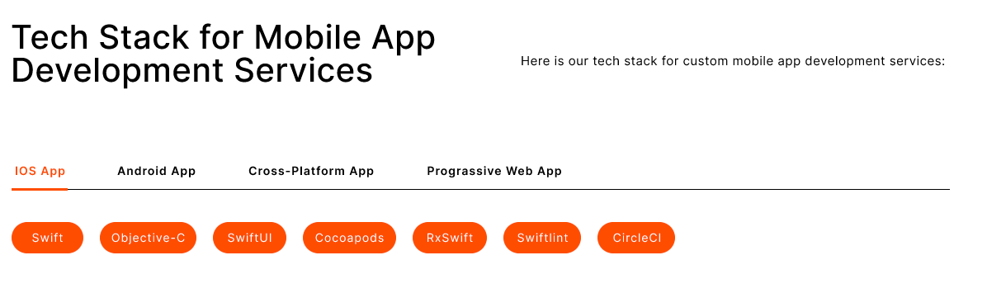

**Innovative Software Development Solutions, Driven by Dynamic Tech Stacks**

We offer custom software products powered by state-of-the-art technology.

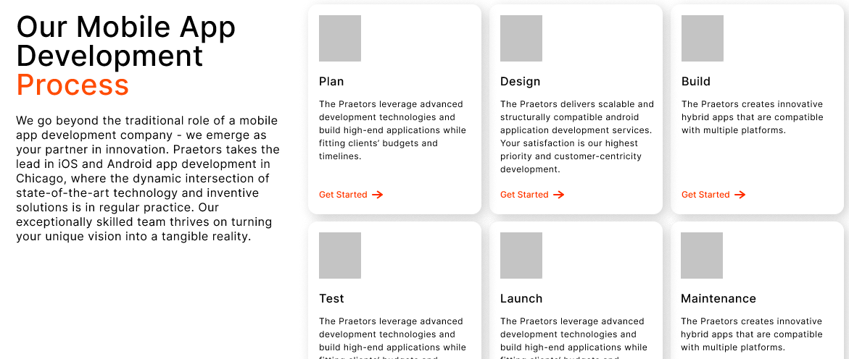

**Discover Our Methodical Software Development Process**

Our custom software development process is carefully structured, with a primary focus on personalized user experiences and the creation of exceptionally efficient solutions. Through our comprehensive range of services, we establish a transparent and dependable partnership, ensuring the delivery of impactful and groundbreaking software solutions. With our experienced guidance and never-ending dedication, you can trust us to navigate every aspect of the journey professionally and precisely, driving forward transformative results for your business.

|  |  |
| --- | --- |
| **Discovery** | We begin by understanding your needs and goals and gathering essential information to lay the foundation for our collaboration. |
| **Planning** | With a clear understanding, we develop a detailed plan outlining the scope, timeline, and resources required for the project. |
| **Design** | Our team creates intuitive, user-friendly designs, ensuring the software aligns seamlessly with your vision and objectives. |
| **Development** | Our skilled custom software developers bring the designs to life, meticulously coding and building the software according to the outlined specifications. |
| **Testing** | Rigorous testing procedures are conducted to identify and resolve any issues, ensuring the software meets high quality and functionality standards. |
| **Launch** | Once thoroughly tested and approved, we deploy the software, providing comprehensive support and guidance to ensure a smooth transition and optimal performance. |

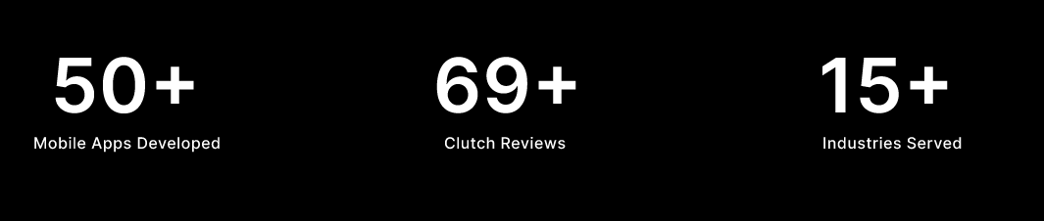

|  |  |  |
| --- | --- | --- |
| **2+**  **Decades of Experience** | **137K+**  **Clients Globally** | **350K+**  **Digital Products Delivered** |

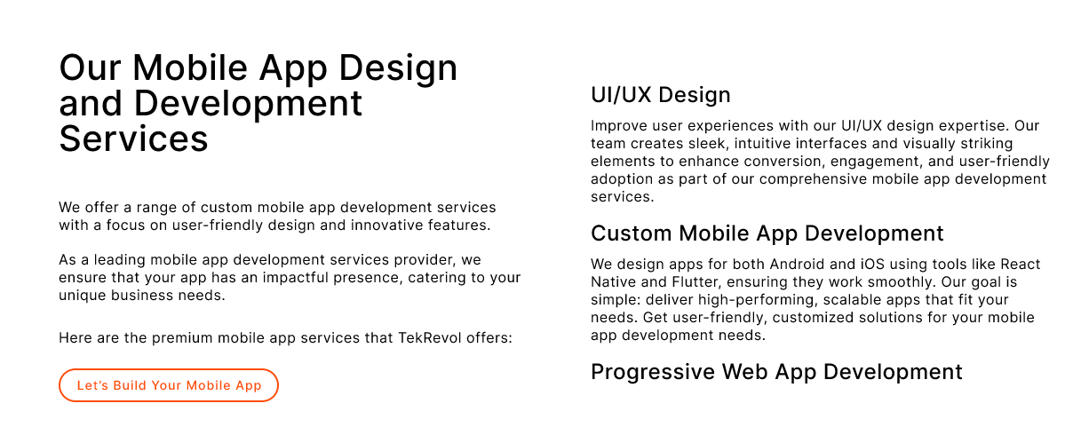

**Our Custom Software Development Services**

The Praetors offers extensive enterprise-level software development solutions to strengthen your business's digital evolution.

With our expert services, we expedite the process of adopting technological advancements to enhance your operational efficiency and competitive edge in the modern landscape.

Trust in our proficiency to tailor innovative software solutions that cater precisely to your unique business requirements and drive tangible results for your organization's growth and success.

|  |  |
| --- | --- |
| **Enterprise Software Solutions**  Designed for efficiency and growth, these solutions optimize operations across various departments, ensuring scalability and seamless integration with existing systems. With a focus on reliability and performance, our software empowers businesses to adapt to evolving demands and drive sustainable success in today's dynamic market landscape. | **Software Prototyping**  Accelerate your product development process with our software prototyping. By quickly creating and testing functional prototypes, we help minimize risks and validate ideas before committing to full-scale development. With rapid iteration and feedback loops, our prototyping approach enables you to bring innovative products to market faster and more confidently. |
| **Web Application Development**  From simple websites to complex web applications, our team leverages the latest technologies and industry best practices to create engaging digital experiences for your target audience. With a focus on usability and performance, we ensure that your web applications meet the highest standards of quality and functionality. | **Cloud-based Software Solutions**  By migrating your applications and data to the cloud, you gain access to scalable infrastructure, enhanced flexibility, and cost-effective IT resources. Our team of cloud experts will work closely with you to design and implement cloud solutions, enabling you to innovate and grow confidently in the digital age. |

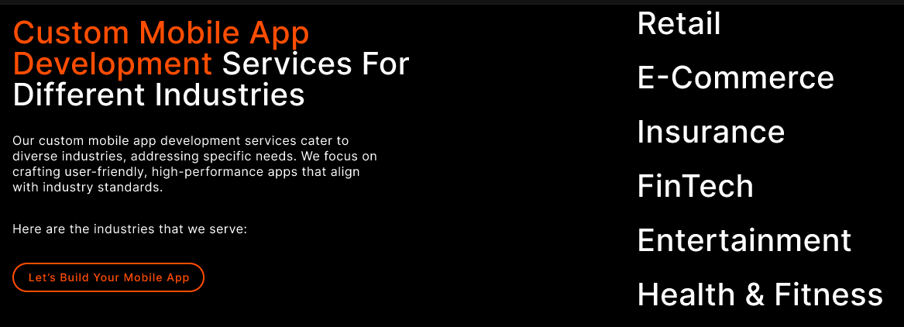

**From Healthcare to Finance: Our Custom Software Development Expertise Knows No Bounds!**

As a custom software development company with an expert team equipped with pro-level skills and the latest tech, we work diligently to understand your requirements and employ advanced digital tools and techniques to deliver effective solutions that deliver positive results.

Trust us to be your reliable partner in navigating the complexities of technology, ensuring your success in today's competitive market.

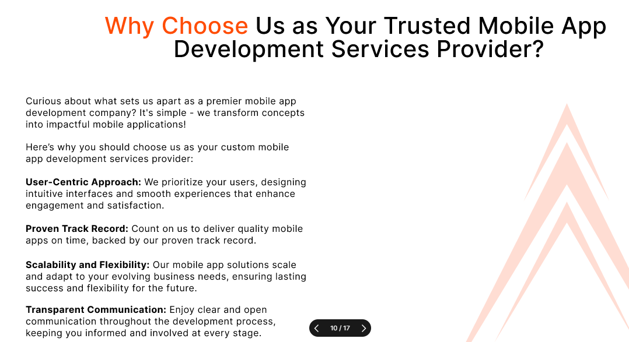

**Our Mission - Empowering Your Journey with Innovation & Integrity**

At our core, our mission is to empower businesses with transformative digital solutions that drive growth and innovation. We are dedicated to leveraging our expertise and creativity to craft bespoke software that meets each client's unique needs and challenges.

Our commitment to excellence guides every aspect of our work, from initial concept to final delivery. We prioritize transparency, communication, and collaboration to ensure that our clients are always informed and involved throughout the software development process. By fostering strong partnerships built on trust and reliability, we aim to become the go-to digital partner for businesses seeking to thrive in today’s competitive landscape.

Our mission is not just to meet expectations, but to exceed them, delivering tangible results and measurable impact for our clients. With a focus on continuous improvement and adaptation to emerging technologies, we strive to stay at the forefront of the industry, driving innovation and pushing boundaries to help our clients succeed in their digital endeavors.

Top of Form

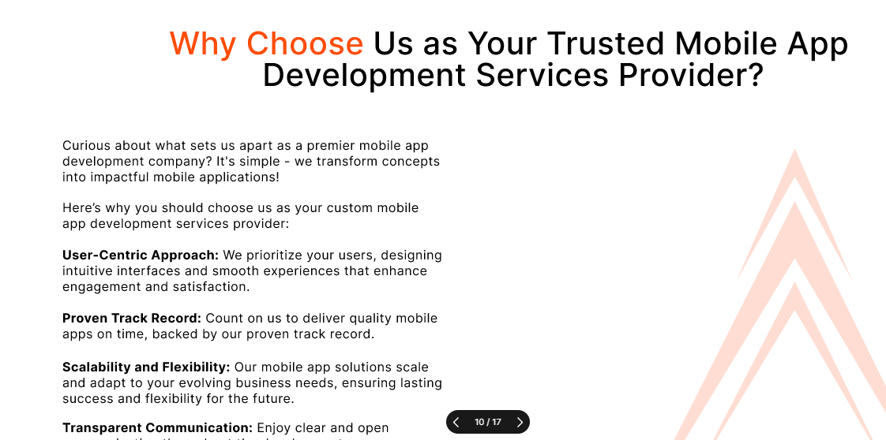

**The Praetors – Custom Software Application Development Company in the USA**

With over two decades of experience in software outsourcing, The Praetors emerges as a seasoned digital partner for businesses looking for performance-driven software integration services.

Our extensive expertise encompasses an in-depth understanding of organizational culture, strategic utilization of a diverse global talent pool, effective cost management, growth-oriented approaches, and unwavering commitment to transparency.

Leveraging globally dispersed teams and on-shore facilities strategically located in the USA, UK, and Asia, we facilitate global enterprises in their journey of innovation and business transformation.

|  |  |
| --- | --- |
| **Quality Products** | We’re all about delivering top-notch stuff, making sure it's spot-on and totally reliable, so you're always happy with what you get. |
| **Robust Development** | When we build custom software, we make sure it's super tough and can handle whatever you need it to do. That's how we roll! |
| **Latest Tech Stack** | We’re all about using the coolest, newest tech to make awesome custom software that's ahead of the game and helps your business grow. |
| **Complete Transparency** | We’re open books here, keeping you in the loop every step of the way so you know exactly what's happening with your custom software development project. No secrets here! |

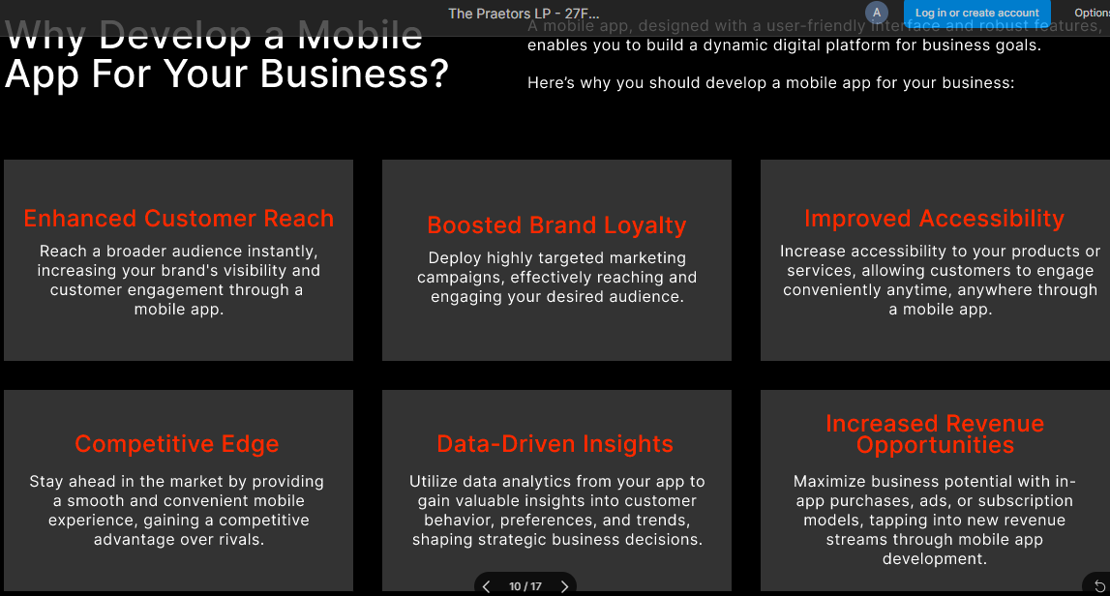

**Why Opt For Custom Software Development For Your Business?**

Custom software development is tailored specifically to your business needs, offering unique solutions that off-the-shelf software can't provide. It enhances efficiency, streamlines processes, and boosts productivity, giving you a competitive edge in the market.

With custom software, you have full control over features and functionalities, ensuring it aligns perfectly with your business goals and objectives.

|  |  |  |
| --- | --- | --- |
| **Customized Solutions**  Tailored to your specific business needs, custom software development offers solutions designed exclusively for your operations, ensuring optimal functionality and efficiency. | **Scalability**  With custom software development, your system can easily adapt and grow alongside your business, accommodating increased workload and expanding requirements without compromising performance. | **Enhanced Security**  Custom software provides robust security measures tailored to your business, offering protection against potential cyber threats and ensuring the safety of your sensitive data. |
| **Integration Capabilities**  Custom software seamlessly integrates with existing systems and applications within your organization, facilitating smooth workflow and eliminating data silos. | **Cost-effectiveness**  While initial development costs may be higher, custom software development eliminates recurring licensing fees associated with off-the-shelf solutions, resulting in long-term cost savings for your business. | **Competitive Advantage**  By leveraging custom software tailored to your unique business processes, you gain a competitive edge in the market, allowing you to innovate, differentiate, and stay ahead of the competition. |

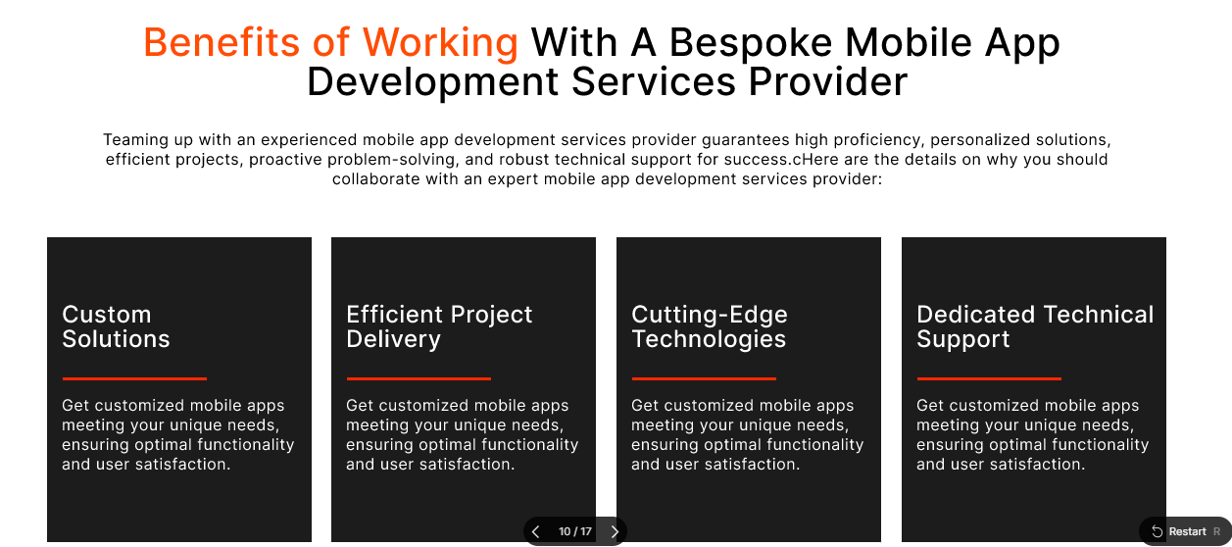

**Benefits of Working With A Professional & Reliable Custom Software Development Company**

Partnering with The Praetors offers numerous benefits. From expert guidance and streamlined communication to high-quality solutions and timely delivery, you can trust in our expertise to enhance your business operations and drive growth in today’s competitive market landscape.

|  |  |  |  |
| --- | --- | --- | --- |
| **Future-Ready Products**  We're all about staying ahead of the game, crafting innovative solutions that'll tackle tomorrow's challenges head-on. | **Dedicated Team**  Count on us to bring your ideas to life! Our custom software developers are dedicated, skilled, and ready to make your vision a reality. | **Customer Experience**  We’re here to make your experience seamless and personalized, tailored just for you and your success. | **Satisfaction Guarantee**  Your satisfaction is our top priority. We're committed to making sure you're thrilled with the results. |

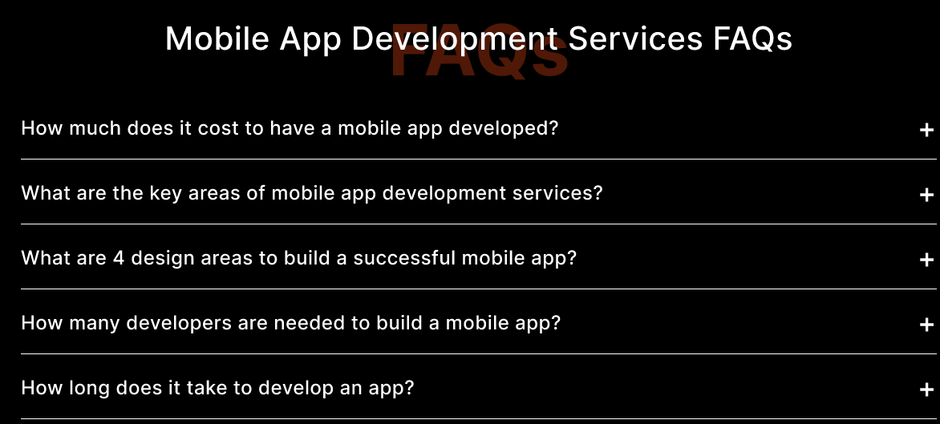

**Custom Software Development Services FAQs**

**1. How long does it take to develop custom software?**

The custom software development timeline varies based on project complexity, features, and client requirements. Generally, it can range from a few weeks to several months.

**2. What factors influence the cost of custom software development?**

Several factors affect the cost, including project scope, complexity, required features, development time, and the hourly rate of developers. Contact us to discuss your project details for an accurate estimate.

**3. Can custom software integrate with existing systems?**

Yes, custom software can seamlessly integrate with existing systems and applications within your organization, ensuring smooth data flow and workflow efficiency.

**4. How do you ensure data security and privacy in custom software?**

We implement robust security measures such as encryption, access controls, and regular security updates to safeguard sensitive data from unauthorized access or breaches.

**5. What ongoing support and maintenance options are available for custom software?**

We offer ongoing support and maintenance services post-launch, including bug fixes, updates, feature enhancements, and technical support to address any issues that may arise.

**6. How can I ensure the custom software meets my specific business needs and requirements?**

Thorough requirements gathering and analysis are conducted at the project’s onset. Close collaboration between our team and stakeholders ensures understanding and addressing all requirements, aligning the software perfectly with your business goals. Top of Form

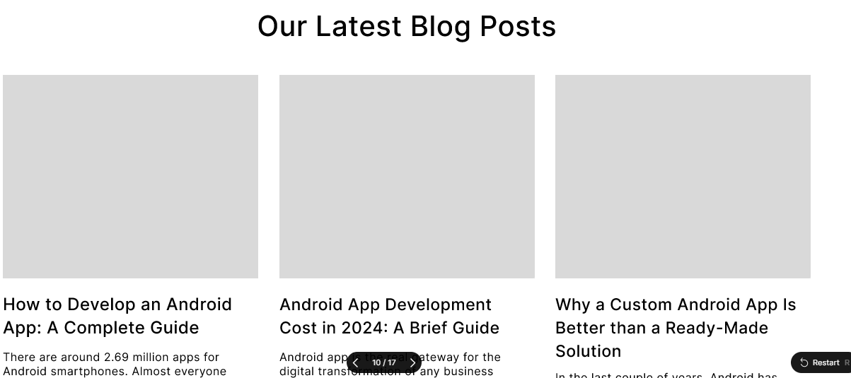

**READ OUR LATEST BLOG**

**[BLOGS HERE]**

# ANDROID APP DEVELOPMENT

**META TITLE**: Android App Development Services | The Praetors

**META DESCRIPTION**: Strengthen your business with our custom Android application development services. Expert development, intuitive design, and seamless user experiences. Contact us now!

**URL**:



**ANDROID APP DEVELOPMENT SERVICES**

In today's fast-paced digital landscape, Android apps play a pivotal role in connecting businesses with their target audience. The Praetors is a professional Android application development agency in the USA that excels in crafting bespoke mobile apps that cater to our clients' unique needs and aspirations. Our comprehensive Android app development services are tailored to leverage the full potential of the Android platform and deliver exceptional user experiences.



**Partner with Custom Android App Development Company for Robust, Performance-Driven Apps!**

We understand that each business has its own set of objectives and challenges. That's why we take a personalized approach to Android app development, starting with a thorough analysis of our clients' requirements and goals.

Our team works closely with clients to conceptualize, design, and develop custom Android applications that resonate with their brand identity and meet the demands of their target market.



**Seamlessly Connect with Your Audience Through Our Android App Development Services**

Backed by a team of seasoned Android app developers, we bring expertise and creativity to every project we undertake. From crafting clean and efficient code to implementing innovative features, our developers ensure that each app we deliver is of the highest quality.

With a focus on usability, performance, and security, we strive to exceed our clients' expectations and deliver solutions that make an impact.

|  |  |
| --- | --- |
| **Cross-Platform Compatibility** | Ensure seamless performance across various platforms, including iOS and Android, to reach a broader audience base. Expand your app's accessibility and maximize user engagement with consistent experiences on all devices. |
| **Customizable User Interface** | Tailor your app's design and layout to reflect your brand identity and resonate with your target audience. From color schemes to navigation menus, offer a personalized user experience that fosters brand recognition and user satisfaction. |
| **Robust Security Measures** | Implement advanced security protocols and encryption techniques to safeguard user data and protect against cyber threats. Prioritize user privacy and build trust by ensuring that your app adheres to industry standards for data protection and secure transactions. |



**Innovative Android App Development, Driven by Dynamic Tech Stacks**

We offer custom Android apps powered by state-of-the-art technology.



**Our Andoird App Development Process**

Our proficient workflow stands as the cornerstone of our achievements as a leading custom Android app development company. With flawless oversight at every stage, we harness premier resources to engineer resilient Android applications. Our adept team of developers upholds industry-standard principles throughout the development cycle, ensuring excellence in execution.

|  |  |
| --- | --- |
| **Discovery** | We begin by understanding your needs and goals and gathering essential information to lay the foundation for our collaboration. |
| **Planning** | With a clear understanding, we develop a detailed plan outlining the scope, timeline, and resources required for the project. |
| **Design** | Our team creates intuitive, user-friendly designs, ensuring the app aligns seamlessly with your vision and objectives. |
| **Development** | Our skilled Android app developers bring the designs to life, meticulously coding and building the app according to the outlined specifications. |
| **Testing** | Rigorous testing procedures are conducted to identify and resolve any issues, ensuring the app meets high standards of quality and functionality. |
| **Launch** | Once thoroughly tested and approved, we deploy the application, providing comprehensive support and guidance to ensure a smooth transition and optimal performance. |



|  |  |  |
| --- | --- | --- |
| **2+**  **Decades of Experience** | **137K+**  **Clients Globally** | **350K+**  **Digital Products Delivered** |



**Explore Our Game-Changing Android App Development Services**

We specialize in developing cutting-edge Android applications tailored to enhance your business's digital presence. Our dedicated Android app developers ensure a seamless user experience and integrate innovative features to meet your specific requirements.

Discover our range of bespoke Android app development solutions designed to drive your business forward. Top of Form

|  |  |
| --- | --- |
| **Android App Development Consultation**  We bridge the gap between your ideas and Android user expectations. Our consultants tailor strategies to align your business with Android users' needs, helping you make informed choices to stand out in the app store. | **Android UI/UX Design**  Our design team creates exclusive experiences within the Android ecosystem. Trust us to craft seamless user experiences that resonate across all Android devices, ensuring your app stands out and effectively engages users. |
| **Android Application Development**  Leverage our expertise to build robust and scalable solutions using the latest stack. Our custom Android app services cater to various industries, ensuring your app represents your unique identity amidst competition in the app store. | **Android Software Testing**  We employ a mix of automated and manual testing to ensure your app meets quality standards. Our testing process maintains a secure and performance-centric approach, delivering a glitch-free experience for your Android mobile application. |



**Our Android App Developers Offer Industry-Specific App Development Services**

When you partner with The Praetors for Android app development, you're choosing a hassle-free journey to digitize your business. Our comprehensive approach ensures a top-notch experience, taking care of all the details.

Explore our expertise across various industries and discover tailored solutions that set your business apart in the digital landscape.



**Our Mission - Empowering Your Journey with Innovation & Integrity**

At our core, our mission is to empower businesses with transformative digital solutions that drive growth and innovation. We are dedicated to leveraging our expertise and creativity to craft bespoke digital products that meet the unique needs and challenges of each client.

Our commitment to excellence guides every aspect of our work, from initial concept to final delivery. We prioritize transparency, communication, and collaboration to ensure that our clients are always informed and involved throughout the Android app development process. By fostering strong partnerships built on trust and reliability, we aim to become the go-to digital partner for businesses seeking to thrive in today’s competitive landscape.

Our mission is not just to meet expectations, but to exceed them, delivering tangible results and measurable impact for our clients. With a focus on continuous improvement and adaptation to emerging technologies, we strive to stay at the forefront of the industry, driving innovation and pushing boundaries to help our clients succeed in their digital endeavors.



**Unlock the Power of Android App Development with The Praetors**

When you partner with The Praetors, a leading and reliable Android app development company in the US, you’re selecting a seasoned team of experts poised to transform your concepts into successful applications.

We commence by attentively listening to your requirements, ensuring a thorough comprehension of your aspirations.

Subsequently, our adept Android app developers utilize their technical prowess to craft applications that not only function seamlessly but also delight end users.

Our commitment extends beyond development; we pledge ongoing support and updates to maintain the excellence of your application, allowing you to concentrate on business growth and customer satisfaction.

|  |  |
| --- | --- |
| **Quality-First Approach** | We’re all about delivering top-notch stuff, making sure it's spot-on and totally reliable, so you're always happy with what you get. |
| **Robust Development** | When we build a custom Android app, we make sure it’s brilliant in every way and functions fully, handling whatever you need it to do. That’s how we roll! |
| **Latest Tech Stack** | We’re all about using the coolest, newest tech to make an awesome custom app that’s ahead of the game and helps your business grow. |
| **Complete Transparency** | We’re open books here, keeping you in the loop every step of the way so you know exactly what's happening with your custom Android app development project. No secrets here! |



**Why Opt For Custom Android App Development For Your Business?**

With a dominant market share of 70.5 percent in the third quarter of 2023, Android solidified its position as the world's leading mobile operating system. This underscores the strategic importance of having an Android app for your business.

An Android app not only expands your customer base but also elevates customer engagement, making it a vital asset for your business growth.

|  |  |  |
| --- | --- | --- |
| **Unlock a Global Audience**  Android apps broaden your market horizon, connecting you with a diverse global audience and extending your reach beyond borders. | **Engage Directly with Customers**  Apps offer a direct and interactive platform for fostering deeper connections with customers, nurturing stronger relationships, and enhancing brand loyalty. | **Boost Visibility**  With your app readily accessible on users' devices, your business gains increased visibility, ensuring easy access and visibility in the competitive digital landscape. |
| **Fostering Customer Loyalty**  The convenience and personalized experience provided by your app fosters strong customer loyalty, driving repeat business and advocacy. | **Precision Targeting**  Leverage apps to execute highly targeted marketing campaigns, delivering tailored messages to the right audience at the right time. | **Enhanced User Experience**  Deliver seamless and user-friendly interactions through your app, enhancing your brand's reputation and ensuring a positive user experience. |



**Perks of Working with an Expert Android App Development Company**

Partnering with The Praetors ensures a seamless journey towards digital transformation through Android app development. We carefully handle every aspect to deliver a superior experience, allowing you to effortlessly focus on your business growth.

|  |  |  |  |
| --- | --- | --- | --- |
| **Future-Ready Products**  We're all about staying ahead of the game, crafting innovative solutions that'll tackle tomorrow’s challenges head-on. | **Dedicated Team**  Count on us to bring your ideas to life! Our Android app developers are dedicated, skilled, and ready to make your vision a reality. | **Customer Experience**  We’re here to make your experience seamless and personalized, tailored just for you and your success. | **Satisfaction Guarantee**  Your satisfaction is our top priority. We’re committed to making sure you’re thrilled with the results. |



**Android App Development FAQs**

**How long does it take to develop an Android app?**

The time required to develop an Android app varies based on its complexity, features, and customization needs. Typically, it can take anywhere from a few weeks to several months.

**What factors influence the cost of Android app development?**

Several factors impact the cost, including the app’s complexity, features, design, development hours, testing, maintenance, and post-launch support requirements.

**Do I need to have technical knowledge to develop an Android app?**

While technical knowledge can be helpful, it’s not mandatory. Working with a professional Android app development company allows you to bring your ideas to life without the need for extensive technical expertise.

**How do you ensure the security of Android apps?**

We prioritize security throughout the development process, implementing best practices for data encryption, secure authentication, and robust authorization mechanisms to safeguard user data and prevent unauthorized access.

**Can you assist with publishing the app on the Google Play Store?**

Yes, we provide comprehensive support, including assistance with app store submission, compliance with Google Play Store guidelines, and optimization of app listings for maximum visibility and reach.

**Do you offer ongoing maintenance and support for Android apps?**

Absolutely. We offer maintenance and support services post-launch to ensure your app remains up-to-date, secure, and optimized for performance. Our team is available to address any issues, implement updates, and provide technical assistance as needed.



**READ OUR LATEST BLOG**

**[BLOGS HERE]**

# IOS APP DEVELOPMENT

**META TITLE**: iOS App Development Services | The Praetors

**META DESCRIPTION**: Unlock the potential of iOS with custom app development. Expertly crafted iOS apps for enhanced user experiences and business growth. Explore our iOS app development solutions today!

**URL**:



**Top iOS App Development Company**

The Praetors stands out as a premier iPhone app development partner for ambitious entrepreneurs and enterprise clients alike. Our focus on user-centric design and innovation ensures that each custom iOS app we create delivers exceptional value, doubling our clients’ return on investment.



**Partner with Professional iOS App Development Company for Robust, Performance-Driven Apps!**

With over 2+ decades of dedicated experience in iOS app development, our team has honed the art of transforming your ideas into remarkable applications. We specialize in crafting iOS apps that captivate users with their seamless functionality and stunning design. Utilizing agile methodologies and technical prowess, we ensure your app's swift and successful delivery.

Entrust us with navigating the intricacies of iPhone app development to strengthen your brand’s digital presence and provide users with an unparalleled mobile experience that keeps them engaged and coming back for more. Let us help you unlock the full potential of your iOS app idea and confidently achieve your business objectives.



**Cutting-edge iOS App Development Services Designed for Success and Growth!**

Experience a transformative journey with our iPhone app development services, designed to steer your business towards new heights of success in the digital landscape. We specialize in crafting mobile applications that not only penetrate the market effectively but also deliver substantial value to your audience.

Our mission is to provide flawless iOS app development solutions that exceed our clients’ expectations and drive success. Let us be your partner in achieving excellence in the world of mobile technology.

|  |  |
| --- | --- |
| **Cross-Platform Compatibility** | Ensure seamless performance across various platforms, including iOS and Android, to reach a broader audience base. Expand your app’s accessibility and maximize user engagement with consistent experiences on all devices. |
| **Customizable User Interface** | Tailor your app’s design and layout to reflect your brand identity and resonate with your target audience. From color schemes to navigation menus, offer a personalized user experience that fosters brand recognition and user satisfaction. |
| **Robust Security Measures** | Implement advanced security protocols and encryption techniques to safeguard user data and protect against cyber threats. Prioritize user privacy and build trust by ensuring that your app adheres to industry standards for data protection and secure transactions. |



**Innovative iOS App Development, Driven by Dynamic Tech Stacks**

We offer custom-made iPhone apps powered by state-of-the-art technology.



**Our Efficient iPhone App Development Process**

Our efficient workflow is the foundation of our success as a top iOS app development company. We manage each phase carefully, using high-quality resources to create robust iPhone apps. Following industry standards closely, our experienced iOS team ensures smooth development cycles and delivers excellence at every step. Trust us to bring your iOS app ideas to fruition with expertise and dedication.

|  |  |
| --- | --- |
| **Discovery** | We begin by understanding your needs and goals and gathering essential information to lay the foundation for our collaboration. |
| **Planning** | With a clear understanding, we develop a detailed plan outlining the scope, timeline, and resources required for the project. |
| **Design** | Our team creates intuitive, user-friendly designs, ensuring the app aligns seamlessly with your vision and objectives. |
| **Development** | Our skilled iOS app developers bring the designs to life, fla coding and building the app according to the outlined specifications. |
| **Testing** | Rigorous testing procedures are conducted to identify and resolve any issues, ensuring the app meets high standards of quality and functionality. |
| **Launch** | Once thoroughly tested and approved, we deploy the application, providing comprehensive support and guidance to ensure a smooth transition and optimal performance. |



|  |  |  |
| --- | --- | --- |
| **2+**  **Decades of Experience** | **137K+**  **Clients Globally** | **350K+**  **Digital Products Delivered** |



**Explore Our Game-Changing iOS App Development Services**

Discover the transformative iPhone app development solutions offered by The Praetors. Our services are designed to revolutionize user experiences and drive business growth. With our game-changing approach, we deliver innovative iOS applications that set new industry standards.

Partner with us to unleash the full potential of your app ideas and take your business to the next level in the digital landscape.

|  |  |
| --- | --- |
| **iOS App Development Consultation**  As a prominent iPhone app development company, The Praetors focuses on understanding your iOS app's unique requirements. Through a detailed assessment, we offer insightful feedback supported by data, aiding in the creation of a comprehensive iOS solution for your brand. | **iOS App UI/UX Design**  Our skilled iPhone app developers prioritize delivering innovative and seamless user experiences. Leveraging their creativity, they design captivating iOS app interfaces that perfectly blend with your business and the Apple ecosystem. |
| **iPhone Application Development**  Our proficient team of strategists, architects, and iOS app designers amalgamate technology, features, and expertise to develop top-notch native iOS mobile apps. We ensure an optimized and flawless user experience for your app. | **iOS App Testing & QA**  We conduct thorough testing and validation to ensure the reliability and functionality of your business-critical iOS applications. Our rigorous testing procedures guarantee that your iOS projects are secure, highly usable, and tailored to your organization's specific requirements.  Top of Form |



**Industries We Serve with Our Performance-Driven iOS App Development**

The Praetors transforms businesses through groundbreaking app solutions, empowering them to maximize their capabilities. Specializing in cutting-edge iOS app development, we create tailored solutions for various industries, reshaping traditional approaches and delivering exceptional results.

Here are the sectors we cater to:



**Our Mission - Empowering Your Journey with Innovation & Integrity**

At our core, our mission is to empower businesses with transformative digital solutions that drive growth and innovation. We are dedicated to leveraging our expertise and creativity to craft bespoke digital products that meet the unique needs and challenges of each client.

Our commitment to excellence guides every aspect of our work, from initial concept to final delivery. We prioritize transparency, communication, and collaboration to ensure that our clients are always informed and involved throughout the iOS app development process. By fostering strong partnerships built on trust and reliability, we aim to become the go-to digital partner for businesses seeking to thrive in today’s competitive landscape.

Our mission is not just to meet expectations, but to exceed them, delivering tangible results and measurable impact for our clients. With a focus on continuous improvement and adaptation to emerging technologies, we strive to stay at the forefront of the industry, driving innovation and pushing boundaries to help our clients succeed in their digital endeavors.



**Choosing The Praetors As Your iPhone App Development Partner**

Partnering with The Praetors for your iOS app development needs offers several advantages. Firstly, we possess extensive knowledge of both traditional and emerging technologies, ensuring we employ the most suitable technology stack and agile methodologies for your project.

Secondly, we boast a team of elite iOS app developers and QA engineers dedicated to ensuring the performance and scalability of your digital assets.

Lastly, we prioritize meeting the evolving needs of your customers, crafting apps with highly functional features that deliver exceptional user experiences.

|  |  |
| --- | --- |
| **Quality-First Approach** | We’re all about delivering top-notch stuff, making sure it's spot-on and totally reliable, so you're always happy with what you get. |
| **Robust Development** | When we build a custom iOS app, we ensure it’s brilliant in all ways and functions fully, handling whatever you need. That’s how we roll! |
| **Latest Tech Stack** | We’re all about using the coolest, newest tech to make an awesome custom app that’s ahead of the game and helps your business grow. |
| **Complete Transparency** | We’re open books here, keeping you in the loop every step of the way so you know exactly what's happening with your custom iOS app development project. No secrets here! |



**Advantages iOS App Development Offers for Your Business Digitization**

With the Apple store dominating the market, accounting for over 62% of global revenue, now is the time to seize the opportunities it offers. iOS apps streamline operations, simplifying processes for both businesses and users. Discover the benefits of iOS app development to boost efficiency and convenience, driving your business towards success.

|  |  |  |
| --- | --- | --- |
| **Boosted Revenue Potential**  iOS app development can drive higher revenue, with iOS users more inclined to make in-app purchases, offering businesses lucrative opportunities. | **Enterprise-ready Features**  iOS offers robust enterprise features like Mobile Device Management (MDM), which streamlines device fleet management for businesses and enhances operational efficiency. | **Robust Security Measures**  iOS prioritizes stringent security, including encryption and theft protection, ensuring customer privacy and data security. |
| **Top-notch Quality Standards**  iOS apps undergo rigorous quality assessments for App Store approval, ensuring flawless performance and building user trust. | **Tech-Savvy Audience**  iOS users are inclined towards innovation, providing businesses with a platform to create cutting-edge apps and influence market dynamics. | **Seamless Integration with Apple Ecosystem**  Opting for iOS ensures seamless integration within the Apple ecosystem, fostering operational efficiency and synergy across your technology infrastructure. |



**Perks of Partnering with a Leading iPhone App Development Company**

When you collaborate with The Praetors, a top-rated iOS app development company, you unlock a pathway to accelerated business growth. Our innovative services offer a multitude of benefits that can maneuver your business forward, ensuring success in the competitive market landscape.

|  |  |  |  |
| --- | --- | --- | --- |
| **Future-Ready Products**  We’re all about staying ahead of the game, crafting innovative solutions that'll tackle tomorrow’s challenges head-on. | **Dedicated Team**  Count on us to bring your ideas to life! Our iOS app developers are dedicated, skilled, and ready to make your vision a reality. | **Customer Experience**  We’re here to make your experience seamless and personalized, tailored just for you and your success. | **Satisfaction Guarantee**  Your satisfaction is our top priority. We’re committed to making sure you’re thrilled with the results. |



**iOS App Development FAQs**

**How long does it take to develop an iOS app?**

The time frame depends on the complexity of the app. Typically, it takes anywhere from 4 to 9 months from concept to launch.

**What is the cost of iOS app development?**

The cost varies based on features, design complexity, and development time. We offer flexible pricing models tailored to your budget and project requirements.

**Do you provide post-launch support and maintenance?**

Yes, we offer comprehensive support and maintenance packages to ensure your app runs smoothly post-launch.

**Can you assist with App Store submission and approval?**

Yes, we guide you through the App Store submission process and ensure compliance with Apple’s guidelines for successful approval.

**Do you offer custom UI/UX design for iOS apps?**

Absolutely; our team of experienced designers creates bespoke UI/UX designs tailored to your brand and user preferences.

**What security measures do you implement in iOS app development?**

We prioritize security with encryption, data protection, secure authentication, and regular security updates to safeguard user data and privacy.



**READ OUR LATEST BLOG**

**[BLOGS HERE]**